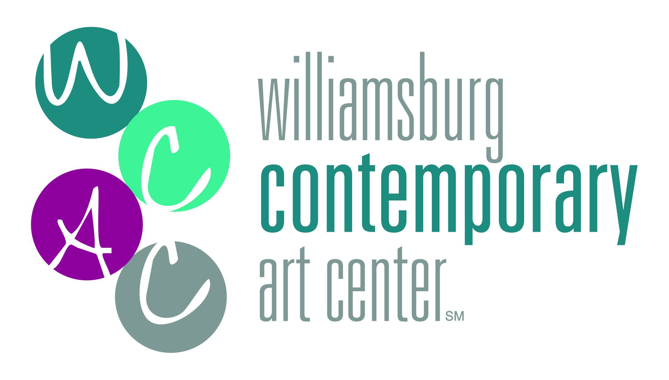 | Thank you for your tax-deductible donation!  Please fill in and print this form (or print first and fill in  by hand) and return it to:  Williamsburg Contemporary Art Center  P.O. Box 388  Williamsburg, VA 23187-0388

 | Old Masters  Kirby Art Society  $5,000 or more |  | Impressionists  Kirby Art Society  $2,500-$4999 |  | Fauvists  Kirby Art Society  $1,000-$2,499
 | Cubists  Kirby Art Society  $500-$999 |  | Surrealists  $250-$499 |  | Friends of Art  $150-$249
 |  |  | Other: $

My Check is enclosed for the amount $
Please make checks payable to Williamsburg Contemporary Art Center

I would like to make a recurring pledge by credit/debit card:
$ monthly $ quarterly $ semi-annually

Charge $ to my credit card: VISA MasterCard AMEX Discover
CARD NUMBER: EXP.DATE (mm/dd): Sec Code:
NAME ON CARD:
SIGNATURE: _______________________________________________

NAME: | (As you would like it published) Please make my gift anonymous
ADDRESS:
PHONE: | EMAIL:

Is your employer a matching gift company? YES / If so, please enclose a matching gift form.

